**MARKET BASKET INSIGHTS**

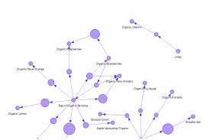

**Definition:** Market basket insights is a data mining technique used by retailers to increase sales by better understanding customer purchasing patterns. It involves analyzing large data sets, such as purchase history, to reveal product groupings, as well as products that are likely to be purchased together.

**Design Thinking:**

1. **Data Source**: Implementation of market basket analysis requires a background in statistics and data science as well as some algorithmic computer programming skills. For those without the needed technical skills, commercial, off-the-shelf tools exist.

groceries=pd.read_csv('../input/groceries-dataset/Groceries_dataset.csv')  
print(f'Groceries_dataset.csv : **{**groceries.shape**}**')  
groceries.head()

1. **Data Preprocessing**: Association rule mining is the core process of market basket analysis. In this step, algorithms such as the Apriori algorithms or the FP-Growth algorithm are applied to the preprocessed data to discover frequent itemsets and generate association rules.

#Renaming the columns to simple words  
groceries.rename(columns = {'Member_number':'id','itemDescription':'item'}, inplace = True)

1. **Association Analysis**: In market basket analysis, association rules are used to predict the likelihood of products being purchased together. Association rules count the frequency of items that occur together, seeking to find associations that occur far more often the expected.

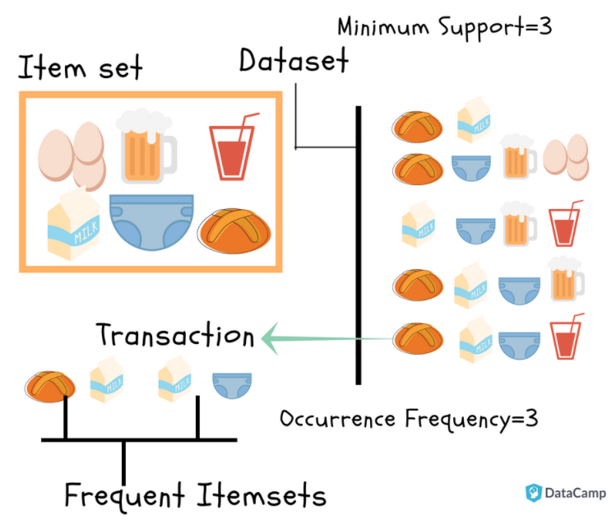

1. **Insights Generation**: These insights can help businesses understand customer behavior, identify product associations, optimize pricing and promotions, enhance cross-selling and upselling strategies, and improve overall business performance.
2. **Visualization**: The results in tabular form will not convey much insights into our algorithm so let’s visualize the rules

**Relationship between the metrics**

|  |
| --- |
| 1 #Setting up the style |
| 2 plt.figure(figsize = (15, 15)) |
| 3 plt.style.use(‘seaborn-white’) |
| 4 #Plotting the relationship between the metrics |
| 5 plt.subplot(221) |
| 6 sns.scatterplot(x=”support”, y=”confidence”, data=rules) |

**Network Diagram of rules**

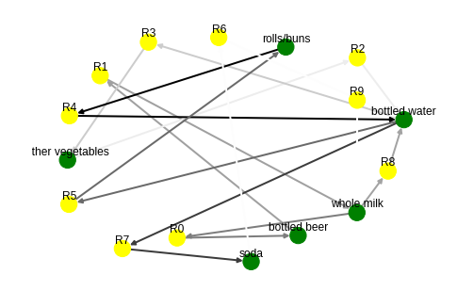

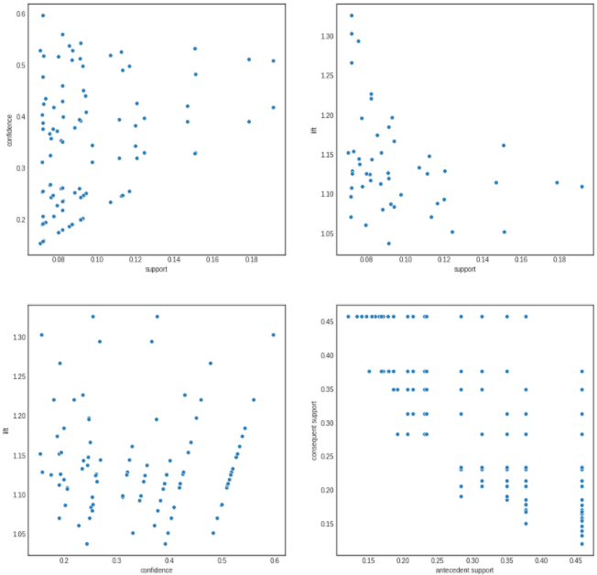

6.**Business Recommendation:**  To use market basket analysis, all we need is impersonal transaction data, such as a transaction ID and which products were purchased. The algorithm analyzes the sum of all past transactions to determine which products are frequently purchased together, allowing us to make real-time, unpersonalised recommendations.

NAME :- AMRIT RAJ

DEPARTMENT :- B.E.- ELECTRONICS AND COMMUNICATION ENGINEERING

YEAR :- 3rd YEAR

REG NO. :- 620821106005

COLLEGE NAME :- GNANAMANI COLLEGE OF TECHNOLOGY

MENTOR NAME :- Dr. K. ANAND (anandped2012@gmail.com)